System Testing:

## 1. Login Form Testing:

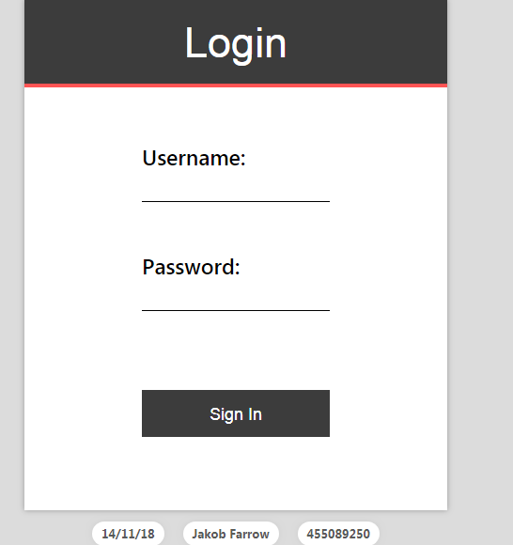

|  |  |  |  |  |  |
| --- | --- | --- | --- | --- | --- |
| Test  Case ID | Test | Expected  Input | Expected  Output | Actual Input | Actual Output |
| 1. | Login Form | Username,  Password | Homepage | No Input  No Input | Homepage |

## 2. Doctor page Testing:

### Doctor Information Form Testing

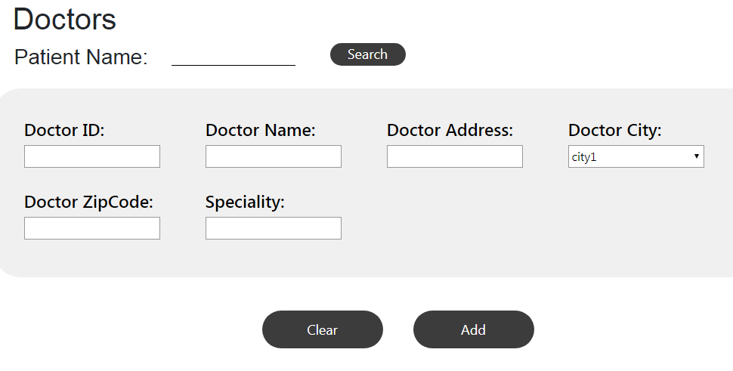

|  |  |  |  |  |  |
| --- | --- | --- | --- | --- | --- |
| Test  Case ID | Test | Expected  Input | Expected  Output | Actual Input | Actual Output |
| 2. | Add Doctor | Add Details of  doctor | Msgbox  Appears(“data is added”) | Add Details of Doctor | Details are added into the database. |

### Doctor cancel Prescription Testing:

|  |  |  |  |  |  |
| --- | --- | --- | --- | --- | --- |
| Test  Case ID |  | Expected  Input | Expected  Output | Actual  Input | Actual  Output |
| 2.B | Mandatory Fields are to be filled to cancel prescription | Enter Patient Name,Date,First and last time Administerd,Status,Doctor Name,Drug name,Last time,Dose,Dose status | Field required error message appears. | Enter  Patient Name | Mandatory Field required  message appears |
|  |  |  |  |  |  |

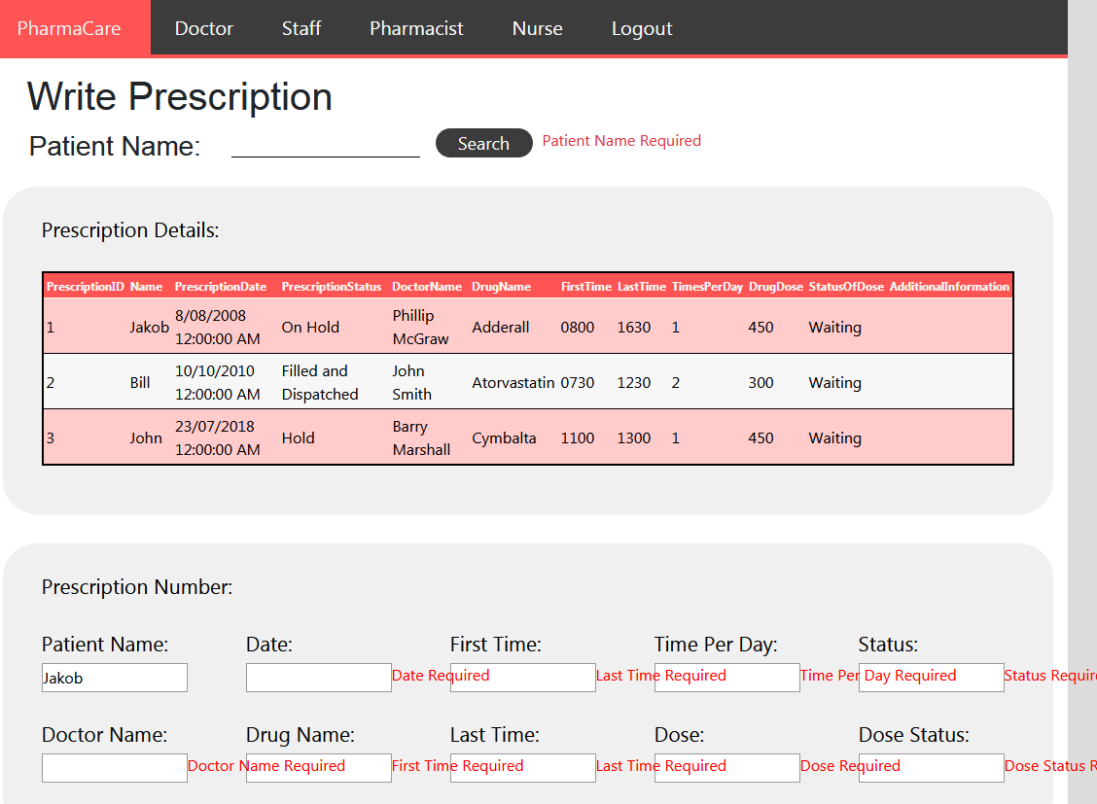

## 3. View Prescription Form Testing

|  |  |  |  |  |  |
| --- | --- | --- | --- | --- | --- |
| Test  Case ID | Test | Expected  Input | Expected  Output | Actual Input | Actual Output |
| 3. | Prescription Details | Enter Patient Name | Prescription details appear | Enter Patient Name | Prescription details appear |

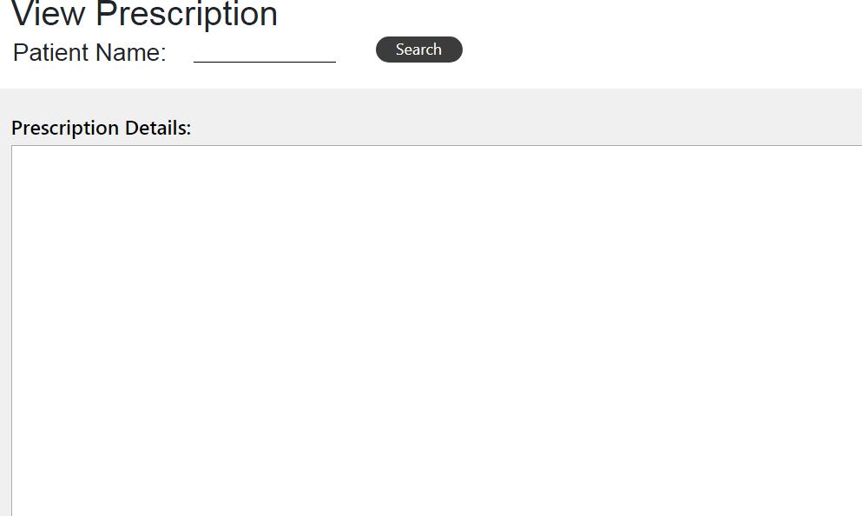

## 4. Pharmacist page Testing

|  |  |  |  |  |  |
| --- | --- | --- | --- | --- | --- |
| Test  Case ID | Test | Expected  Input | Expected  Output | Actual Input | Actual Output |
| 4. | Print Indoor  Prescription Labels | Enter Patient ID | Print Labels | Enter Patient ID | Print Labels |

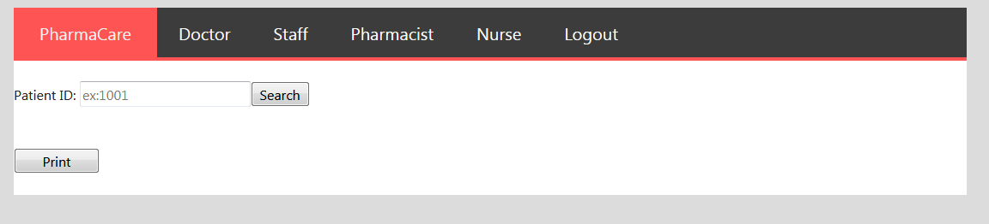

\ 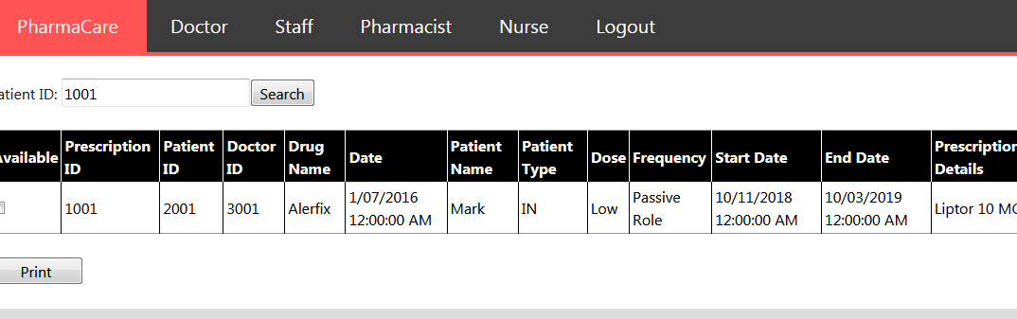

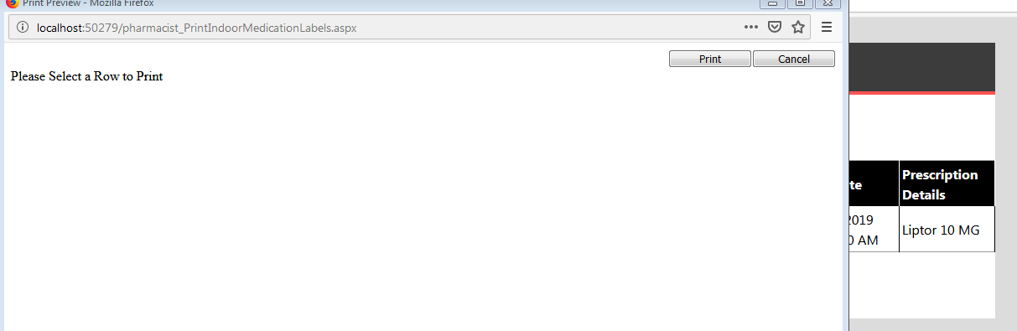

### Pharmacist View Prescription testing:

|  |  |  |  |  |  |
| --- | --- | --- | --- | --- | --- |
| Test Case  ID | Test | Expected  Input | Expected  Output | Actual  Input | Actual  Output |
| 4B | View Patient  Prescription | Enter Patient  Name | Prescription  appears | Enter Patient  Name | Prescription ID  and details appear |

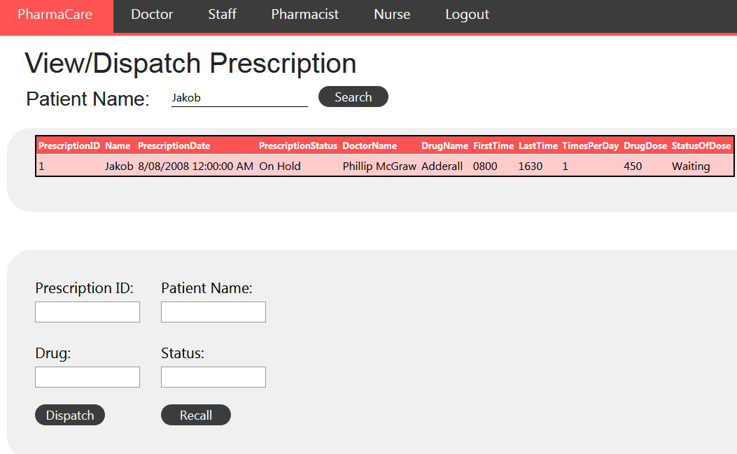

## 5. Nurse Page Testing

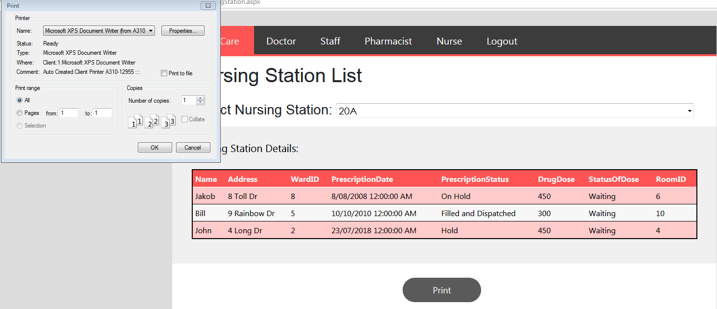

|  |  |  |  |  |  |
| --- | --- | --- | --- | --- | --- |
| Test Case ID | Test | Expected Input | Expected  Output | Actual  Input | Actual Output |
| 5. | Print List for Nursing Station | Select Nursing Station and print the Results | Print Window appears | Select Nursing Station(20A) and press Print button | Print window appears |
|  |  |  |  |  |  |

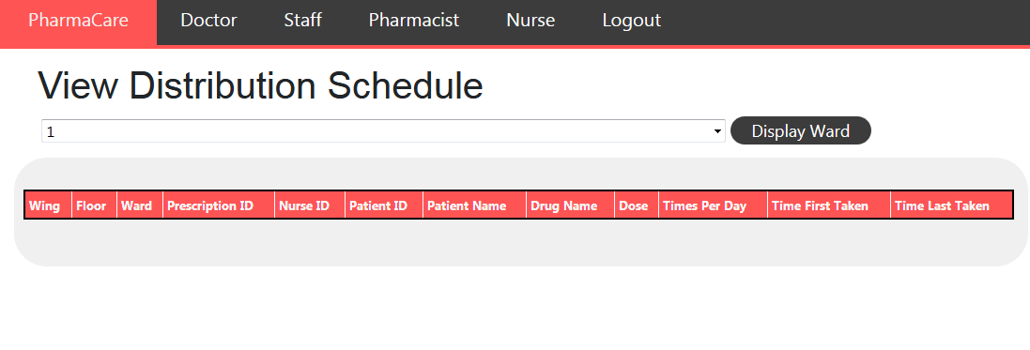

|  |  |  |  |  |  |
| --- | --- | --- | --- | --- | --- |
| **Test Case ID** | **Test** | **Expected Input** | **Expected**  **Output** | **Actual**  **Input** | **Actual**  **Output** |
| **5.B** | **View Distribution Schedule** | **Enter Ward number** | **Distribution schedule should appear** | **Enter Ward number** | **Distribution schedule** |